Name : MUHAMMAD MUBASHAR ALI

Student ID : BSIET02213012

Subject : Object Oriented Programming .

Lab : 09

Example # 01

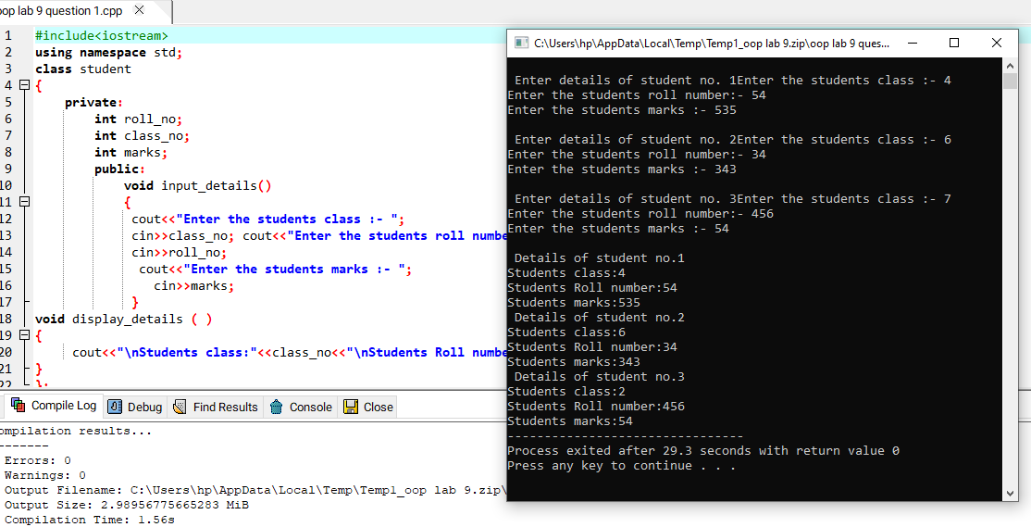

Example # 02

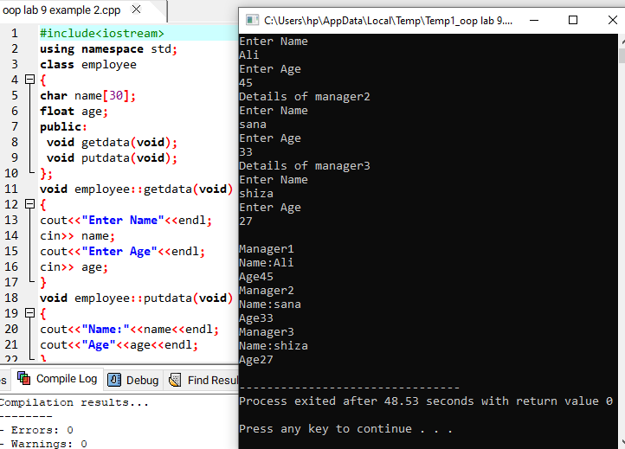

Example # 03

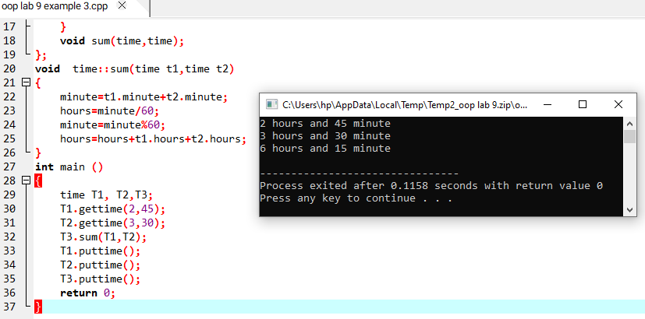

Example #04

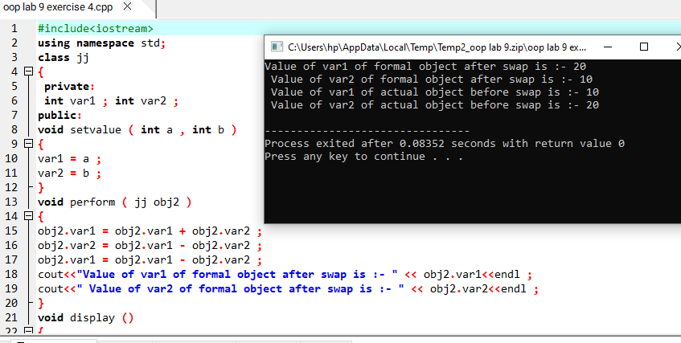

Example # 05

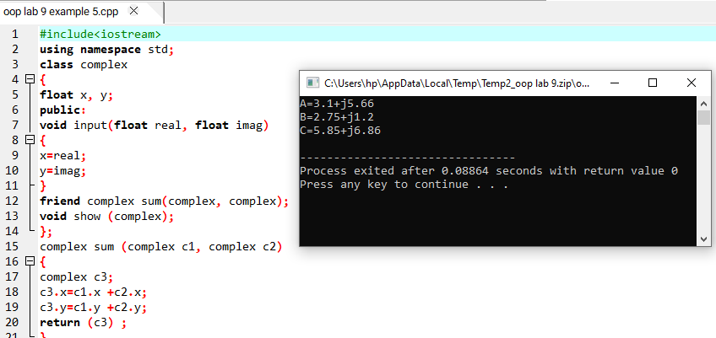

Example # 06

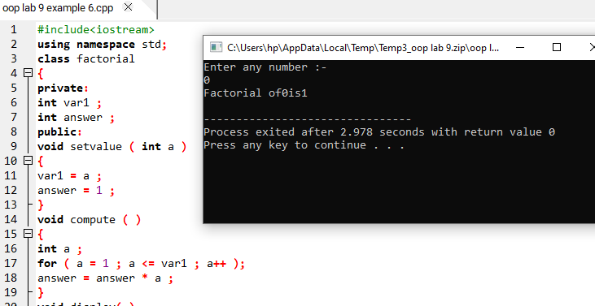

Review Questions

Question # 01

Solved all lab exercise questions and check their output by your lab instructor ?

Answer

All done .

Question # 02

What is class? How does it accomplish data hiding?

Answer

A class is a template to create objects. Methods and variables declared private can not be access outside of the class. Those can be only accessed internally, it means that they are hidden from the outside. It makes programming easier because it is guaranteed that those internal information won't be messed up by outside code.

Question # 03

Can we use the same function name for a member function of a class and an outside function in the same program file?. If yes how are they distinguished? If no, give reasons ?

Answer

Yes. Object of the class is used to distinguish between the member function of a class and a non-member function with same name.

Question # 04

Identify the error in the following program #include using namespace std; class room { int width, height; void setvalue(int w, int h) { width=w; height=h; } }; void main ( ) { room obj1; obj1.width=12; } ??

Answer

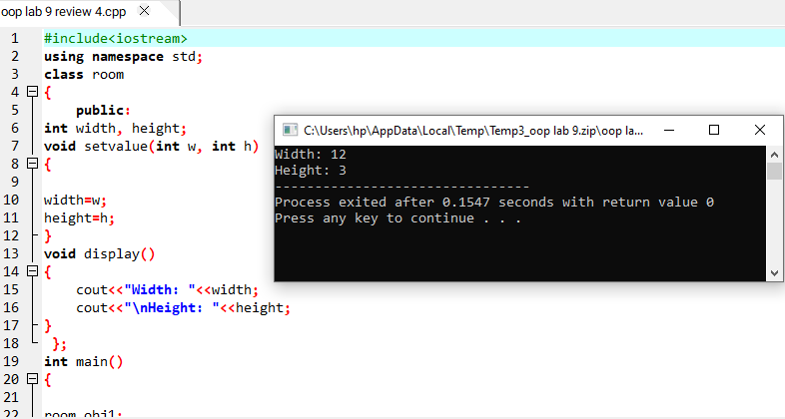

Question # 05

Write a program in C language to define a class to represent a bank account. Include the following members Data members: • Name of the depositor • Account No. • Type of account • Balance amount in the account Member functions: • To assign initial values • To deposit an amount • To withdraw an amount after checking the balance • To display name and balance.??

Answer

